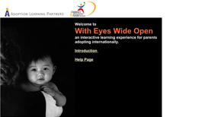

With Eyes Wide Open
A Preparation Guide to International Adoption

Many children available for international adoption have had experiences that will help shape their personalities. Using role playing and thought-provoking exercises, this course helps adoptive parents reconstruct – and understand- the first year of their adopted child’s life with eyes wide open.

The With Eyes Wide Open Course will help adoptive parents:

- Imagine their child’s life during the first year, such as the sounds, foods, rituals and their relationship with caregiver
- Research and prepare for the challenges they and their adopted child will face as they transition to home and beyond
- Think about and plan for how they will parent their adopted child

Credit hours: Determined by your adoption agency
Course fee: $45

(Insert your agency name)

