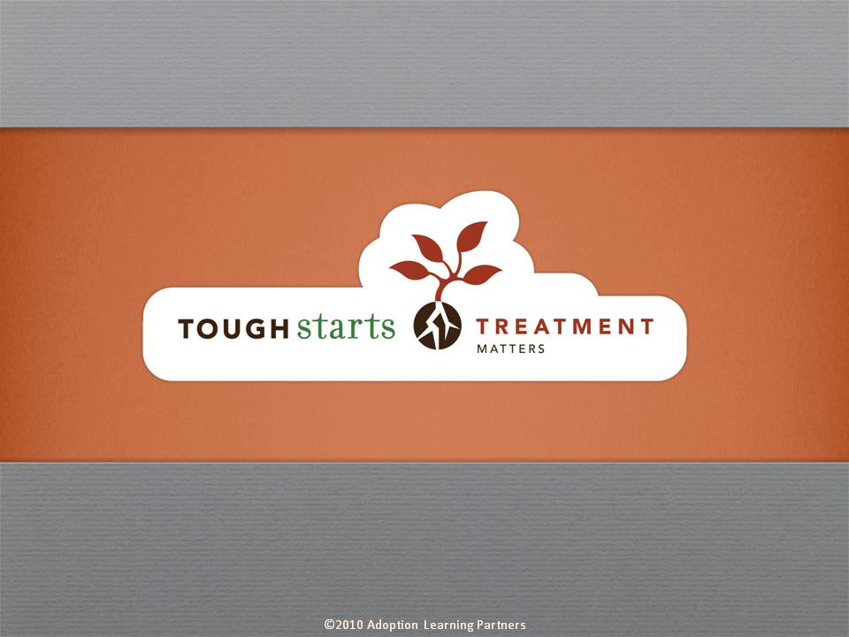

Tough Starts Matter Series:
Treatment Matters

Armed with a deeper understanding of brain development and the impact on a child’s behavior who has had a tough start in life, parents can move on to explore how to best help their child heal. This course, Treatment Matters, gives parents strategies for seeking professional help as soon as they recognize their child has significant challenges.

We discuss how getting a diagnosis can help in prioritizing possible treatments as well as securing appropriate services from a school or insurance provider. We touch on when a parent may want to consider medication for their child, how to choose a therapist and why parents may want to be included in therapy sessions.

The tone of our series is informative, practical and encouraging. Throughout the courses you’ll hear straight from experts who have dedicated their lives to working with tough start kids. These experts are at the forefront of their fields, doing cutting edge research which they share throughout the courses. Parents are reminded that no matter how difficult the child’s beginning, no matter how discouraged they may feel with their parenting experience to date, positive change is always possible.

Credit hours: 1.0

Course fee: $25

(Insert your agency name)

