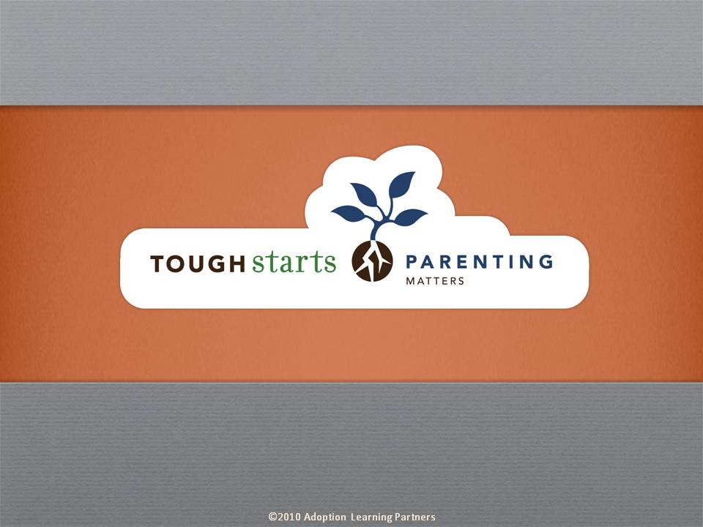

Tough Starts Matter Series:
Parenting Matters

Our Parenting Matters course applies a strengths-based, therapeutic approach to helping parents connect in order to heal their child who has had a tough start in life. This approach to parenting goes well beyond parenting based on instinct or tradition and instead is more deliberate and intentional.

Exercises, family stories and expert advice help instruct parents on how to maximize their own and their child’s strengths in order to offset and work around troublesome vulnerabilities and threats. The goal is to help parents respond to their child more insightfully, therefore more appropriately redirecting negative behavior rather than compounding the child’s issue.

The tone of our series is informative, practical and encouraging. Throughout the courses you’ll hear straight from experts who have dedicated their lives to working with tough start kids. These experts are at the forefront of their fields, doing cutting edge research which they share throughout the courses. Parents are reminded that no matter how difficult the child’s beginning, no matter how discouraged they may feel with their parenting experience to date, positive change is always possible.

Credit hours: 2.0

Course fee: $25

(Insert your agency name)

