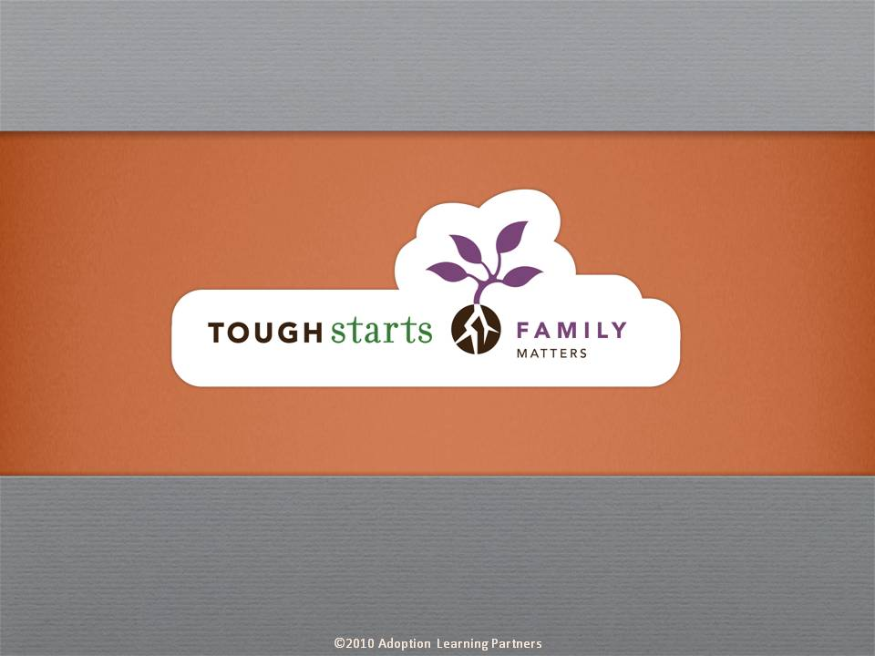

Tough Starts Matter Series:
Family Matters

The goal of Family Matters is to help parents understand the toll raising a tough start child can take on them, their relationships and their other children. The course teaches techniques parents can use to support each member of the family, and themselves, through these challenges.

Many parents feel guilty taking time for themselves, become frustrated or angry at their spouse, and feel helpless when it comes to their other children. Family Matters suggests small steps and offers practical suggestions on how parents can take better care of themselves, their relationship with their spouse, and their other children. Expert advice and real life stories help parents recognize that others may be feeling. Exercises reinforce open communication skills and offer useful, everyday techniques.


The tone of our series is informative, practical and encouraging. Throughout the courses you’ll hear straight from experts who have dedicated their lives to working with tough start kids. These experts are at the forefront of their fields, doing cutting edge research which they share throughout the courses. Parents are reminded that no matter how difficult the child’s beginning, no matter how discouraged they may feel with their parenting experience to date, positive change is always possible.

Credit hours: 1.0

Course fee: $10

(Insert your agency name)

