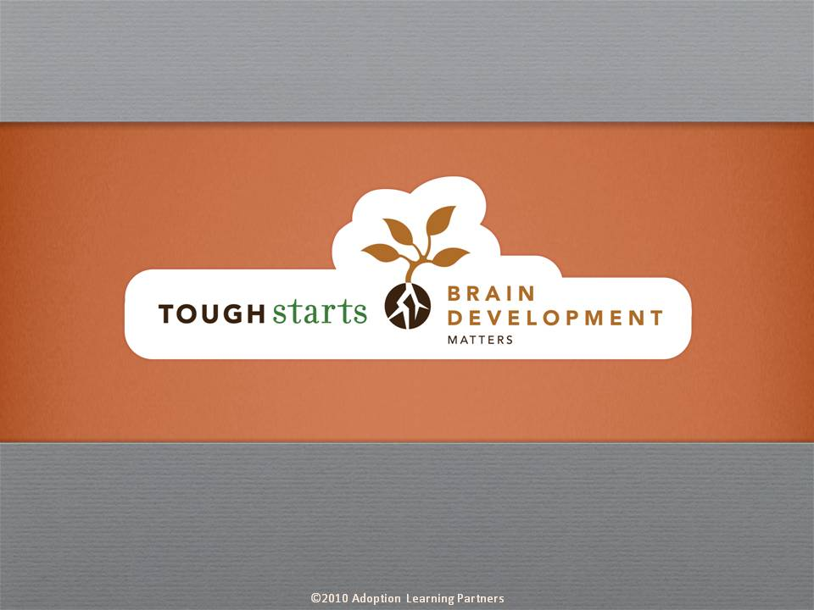

Tough Starts Matter Series:
Brain Development Matters

The objective of Brain Development Matters is to help parents thoroughly understand the impact that early trauma has on a child’s brain chemistry, brain development and sensory processing. Once a parent understands how their child’s brain is connected to his behaviors, these behaviors begin to make more sense.

Instead of feeling defied and disrespected, a parent may now see that this behavior is rooted in how the child is experiencing their world. This paradigm shift can open new doors for more empathetic and effective parenting. With a thorough understanding of brain development, parents are better prepared to learn how to more successfully intervene and shape their child’s troubling behaviors.


The tone of our series is informative, practical and encouraging. Throughout the courses you’ll hear straight from experts who have dedicated their lives to working with tough start kids. These experts are at the forefront of their fields, doing cutting edge research which they share throughout the courses. Parents are reminded that no matter how difficult the child’s beginning, no matter how discouraged they may feel with their parenting experience to date, positive change is always possible.

Credit hours: 1.0

Course fee: $25

(Insert your agency name)

