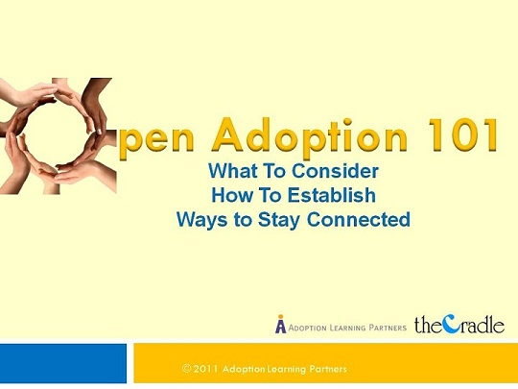

Open Adoption 101:
What to Consider, How to Establish, Ways to Stay Connected

Open adoption can be a scary and difficult relationship to understand. This course will explain open adoption; will help you to understand the expectant parent and birth parent perspectives; and will offer strategies for making openness part of your everyday life.

This course will help prospective adoptive parents:

- Understand the different degrees of openness.
- Become familiar with the process of creating an open adoption.
- Make openness work for them.
- Learn how to maintain connections with birth families.

Credit hours: 2.0

Course fee: $35

(Insert your agency name)

(Insert your agency name and family code)

