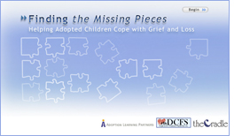

Finding the Missing Pieces:
Helping Adopted Children Cope with Grief and Loss

It is natural for adopted children to grieve the life and family they never knew, no matter how open the adoption or how happy their life with the adoptive family. This course receives consistently high marks from adult adoptees, regardless of how old they were when adopted. It is designed to help adoptive parents:

- Identify the gains and losses experienced by members of the adoption circle.
- Understand the factors that affect the experience of loss.
- Develop strategies for helping children grieve their losses.
- Identify resources to help children and families grieve.
- Understand when to seek professional assistance.

Credit hours: 2.0

Course fee: $35

(Insert your agency name)

