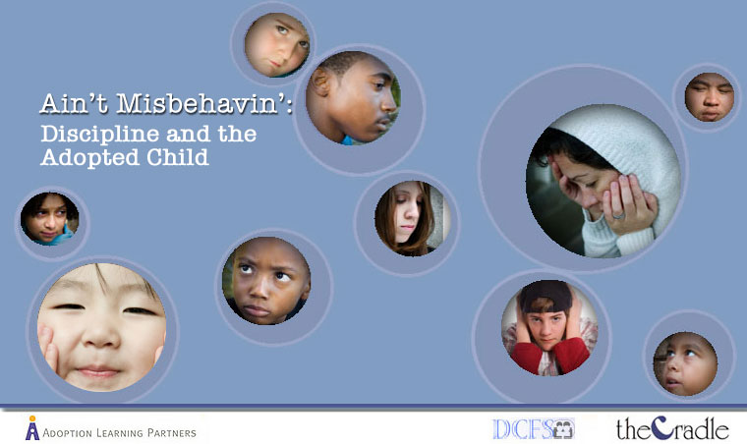

Discipline and the Adopted Child: Ain’t Misbehavin’

Most children will act up at times. And most parents will get frustrated with their children's behavior on occasion. It's just part of being a kid and being a parent. The tricky added element for adoptive families is to understand what role adoption and early or prenatal history play in contributing to difficult behavior.

The goal of this course is to help parents better understand potential causes for challenging behaviors and then develop effective, adoption-friendly discipline plans to address them. By encouraging children to make better behavioral choices, effective discipline results in happier, more connected families.

This course will help an adoptive or foster parent:

- Understand the impact of a child's history on his behavior.

- Understand why discipline is preferable to punishment, especially for adopted children.

- Assess the effectiveness of different discipline strategies.
- Develop a specific plan for their family.

Credit hours: 2.0

Course fee: $35

(Insert your agency name)

