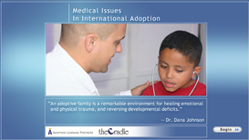

Medical Issues in International Adoption

This course provides an overview of the common medical issues, health risks and specific conditions internationally adopted children may face.

Adoptive parents will develop an understanding for:

- The medical and developmental consequences of institutional or foster care on children
- The medical issues common to their adopted child’s country of origin
- The importance and role of medical and developmental professionals in assessing an internationally adopted child’s health.

Credit hours: 2.5
Course fee: $45

(Insert your agency name)

