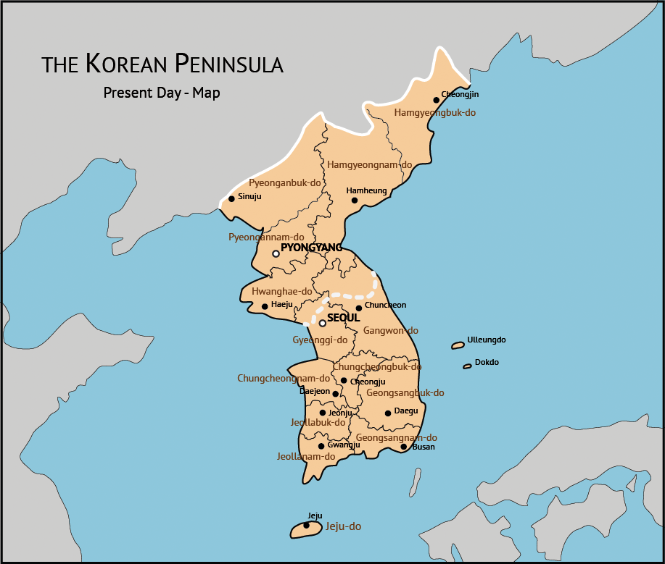

The Republic of Korea: History and Culture

An understanding of your child's heritage is essential to help her connect to her culture. This course is designed to introduce you to the history and culture of Korea.

Credit hours: 1.0

Course fee: $20

(Insert your agency name)

(Insert your agency name)

