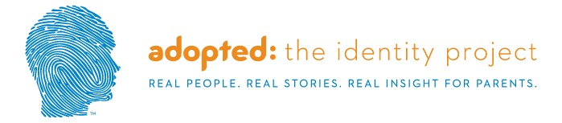

Adopted: The Identity Project

This course guides parents through a series of adoptee stories giving a unique view into the hearts, minds and souls of the adopted person experience. Discussions involve unresolved questions surrounding their birth family, the decision to place them for adoption and how much of who they are is related to their DNA vs. their upbringing. These stories are supported with clinical insights from our expert offering practical tips for parents to use with their own family.
- Adult adoptees reflect on their experiences as children and teens
- Invaluable insights into what their child may be feeling
- Practical tips from our experts for parents to use with their own family

Credit hours: 1.0

Course fee: $19

(Insert your agency name)

