The Hague Package

Five Hague aligned courses
Ten required credit hours

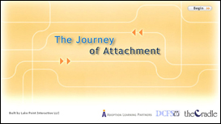 | The Journey of Attachment  - Learn to see attachment as a lifelong process  - Identify factors that affect attachment  - Recognize signs of attachment  - Apply strategies to encourage attachment  - Understand when professional assistance might be necessary
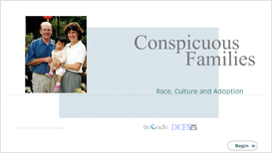 | Conspicuous Families  - Learn new skills for responding to hurtful and insensitive comments and model answers for their child  - Examine the diversity in their life and learn strategies for coloring their world  - Share in the wisdom and collective experiences of adopted persons and adoptive parents with transracial families
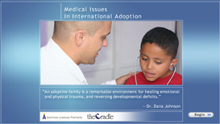 | Medical Issues in International Adoption  - Understand the medical and developmental consequences of institutional or foster care on children  - Learn about medical issues common to their adopted child’s country of origin  - Understand the importance and role of medical and developmental professionals in assessing an internationally adopted child’s health
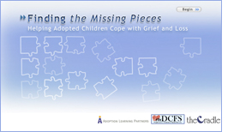 | Finding the Missing Pieces: Helping Adopted children Cope with Grief and Loss  - Identify the gains and losses experienced by members of the adoption circle  - Understand the factors that affect the experience of loss  - Develop strategies for helping children grieve their losses  - Identify resources to help children and families grieve  - Understand when to seek professional assistance
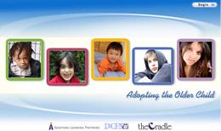 | Adopting the Older Child  - Learn to consider the child’s expectations  - Understand the importance of their child’s history  - Develop strategies for integrating an older child into the existing family unit  - Identify the challenges specific to older adopted children  - Understand when and where to seek assistance

Package Cost: $149
(Insert your agency name)

