The Hague Package - China Edition
Eight Hague aligned courses for China. Twelve required credit hours.

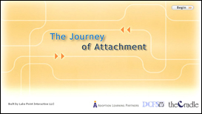 | The Journey of Attachment  - Identify factors that affect attachment  - Recognize signs of attachment  - Apply strategies to encourage attachment
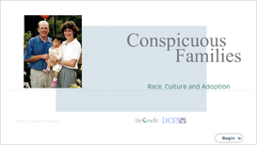 | Conspicuous Families  - Learn new skills for responding to hurtful and insensitive comments and model answers for their child  - Examine the diversity in their life and learn strategies for coloring their world
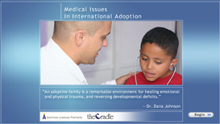 | Medical Issues in International Adoption  - Understand the medical and developmental consequences of institutional or foster care on children  - Learn about medical issues common to their adopted child’s country of origin
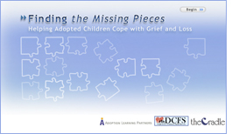 | Finding the Missing Pieces: Helping Adopted children Cope with Grief and Loss  - Identify the gains and losses experienced by members of the adoption circle  - Understand the factors that affect the experience of loss  - Develop strategies for helping children grieve their losses
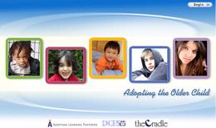 | Adopting the Older Child  - Understand the importance of their child’s history  - Develop strategies for integrating an older child into the existing family unit  - Identify the challenges specific to older adopted children
 | We’re Home! Now What?  - Two courses: one for parents of preschool age children and one for parents of school age children  - Address the immediate issues families face while getting to know one another  - Learn strategies to help related to language, sleep, attachment and medical care
 | China: Her Land & People, History and Philosophies  - Learn about the land and people of China  - Discover Chinese traditional beliefs
 | China: Language Festivals and Traditions  - Gain an understanding of basic Chinese language  - Learn about festivals and traditions you can incorporate into your own family

Package Cost: $179.00

(Insert your agency name)

