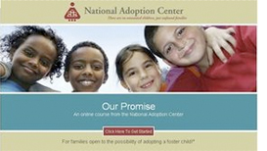

Foster Family to Forever Family

This highly-interactive course is helpful to anyone considering adopting a child from the U.S. domestic foster care system.

This course will help adoptive families:

- Understand the entire process of adopting their foster child
- Prepare their family for the transition to adoptive family
- Prepare a mental and emotional adoption checklist
- Develop guides that will help make the most of their time with adoption professionals
- Become aware of the truth surrounding most common myths and misconceptions regarding adopting children from the foster care system
- Identify the post-adoption resources available to their family

Credit hours: The NAC grants 2.0 credit hours for this course. Please check with your agency or state to see if they accept this credit

Course fee: $10

(Insert your agency name)

