Domestic Infant Adoption Package

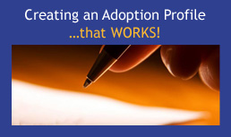 | Creating an Adoption Profile….That WORKS!  - Learn what to include in your profile  - Participate in interactive exercises to help you craft your story  - Understand research based do’s and don’ts  - Identify connection points
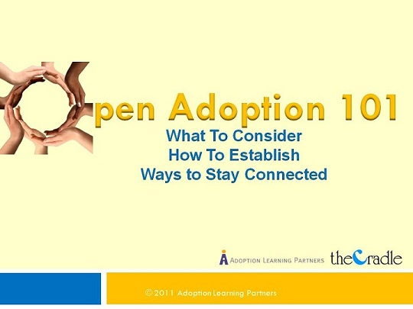 | Open Adoption 101: What to Consider, How to Establish, Ways to Stay Connected  - Understand the different degrees of openness  - Become familiar with the process of creating an open adoption plan  - Make openness work for you  - Learn to maintain connections with birth families
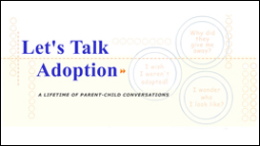 | Let’s Talk Adoption: A Lifetime of Family Conversations  - Learn strategies for addressing questions at each stage of development  - Build a collection of tools for talking about adoption  - Communicate strategies through the analysis of actual parent child dialogues  - Share in the experiences of adoptive parents, adopted persons and professionals

Package Cost: $95
Credit Hours: 6

(Insert your agency name)

