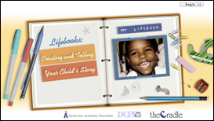

Lifebooks: Creating and Telling Your Child’s Story

A Lifebook is a book created for an adopted child that tells his story, before and after adoption. A Lifebook helps all children place foster care or adoption in the context of their life experiences. The Lifebooks course helps adoptive families:

Understand the purpose of a Lifebook and the need to start or to continue to develop one.
Identify the components of a Lifebook.
Identify the situations that my benefit from employing Lifebooks.
Develop some pages of your adopted child’s Lifebook.
Understand the importance of LIfebooks as a lifelong project.

Credit hours: 1.5

Course fee: $30

(Insert your agency name)

