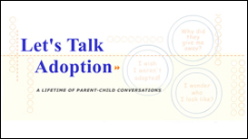

Let’s Talk Adoption:
A Lifetime of Parent-Child Conversations

This course pulls from the wisdom of adoptive parents, adopted persons and adoption professionals to help parents identify and overcome barriers to talking about adoption. Adoptive parents will learn to:

- Explore their child’s developmental stages and learn strategies for addressing questions at each stage.
- Communicate strategies through the analysis of actual parent-child dialogues.
- Build a collection of tools for talking about adoption.
- Share in the wisdom and experience of adoptive parents, adopted persons and professionals through adoption stories

Credit hours: 2.0

Course fee: $35

(Insert your agency name)

