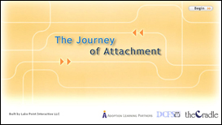

The Journey of Attachment

Attachment is an essential component of any healthy, happy family. Adoption, however, may present challenges to the attachment process. This course provides practical tips on how to form and sustain this important bond. Designed for both first time adoptive parents and parents struggling with attachment issues with their adopted child, this course will help adoptive parents learn to

- See attachment as a lifelong process
- Identify factors that affect attachment
- Recognize signs of attachment
- Apply strategies to encourage attachment
- Understand when professional assistance might be necessary

Credit hours: 2.0

Course fee: $35

(Insert your agency name)

