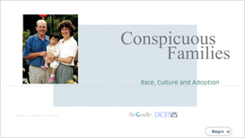

Conspicuous Families: Race, Culture and Adoption

Adopting a child of a different race or ethnicity presents challenges you may not expect. Designed for anyone considering adopting a child with a different racial or ethnic background than their own, this course will help adoptive parents:

- Learn new skills for responding to hurtful and insensitive comments and model answers for their child.
- Examine the diversity in their life and learn strategies for coloring their world.
- Share in the wisdom and collective experiences of adopted persons and adoptive parents with transracial families.

Credit hours: 1.5

Course fee: $30

(Insert your agency name)

