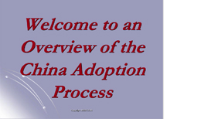

An Overview of the China Adoption Process

This Course gives an overview of the process of adoption from China, including:

- General characteristics and needs of children awaiting adoption in China
- The in-country conditions that affect children in China
- The home study and family assessment process
- The post-adoption process

Please note: This course provides an overview of the process, but does not include agency specific information. As a result, your agency may require you to take a course that they provide that covers much of the same material, but also includes the agency specific information.

Credit hours: 0.5

Course fee: $15

(Insert your agency name)

