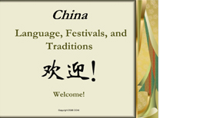

China: Language, Festivals and Traditions

This course provides an overview of the Chinese language and explains some festivals and traditions that you can incorporate into your own family. A great resource for families anticipating an adoption from China as well as those who have already adopted from China.

Credit hours: 0.5

Course fee: $15

(Insert your agency name)

