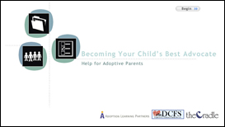

Becoming Your Child’s Best Advocate
Help for Adoptive Parents

Advocacy begins even before a child joins her adoptive family and continues throughout her childhood. Though course content focuses specifically on the needs of adoptive and prospective adoptive parents in Illinois, many of the tips and techniques presented here are useful to all parents, biological and adoptive, no matter where they live.

This course helps adoptive parents:

- Understand why they are the best advocate for their adopted child
- Identify the information needed to develop a complete file of their child’s history
- Determine their family’s current need for services and project possible future needs
- Recognize resources available to their child and determine eligibility requirements
- Match their child’s and family’s needs with available resources

Credit hours: 2.0
Course fee: Certificates of Completion are available for a fee of $35

(Insert your agency name)

