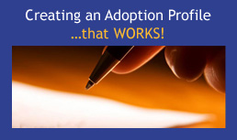

Creating an Adoption Profile that Works!
Express yourself and Connect

For many hoping to adoption a newborn domestically, the task of creating a family profile can be daunting. What should you say? What should you avoid? How can you stand out from the crowd?

Make the first step in connecting with expectant parents considering adoption a good one by creating a compelling adoption profile that truly highlights who you are. A profile that creatively expresses who you really are offers expectant parents a window into your life and connect with you in particular.

This course offers:

- Tips on what to include
- Interactive exercises to help you craft your story
- Ideas to help you consider connection points to highlight in your profile
- Research on what works and what doesn’t (i.e. profile Do’s and Don’ts)

Credit hours: 2.0

Course fee: $40

(Insert your agency name)

(Insert your agency name and family code)

